A Minor Project Proposal Report on

**Exam Hall Seating Management System**

Submitted in Partial Fulfillment of the Requirements for the Degree of **Bachelor in Information Technology** Under Pokhara University

Submitted by:-

**Pawan Upreti, 161517**

**Sushil Phuyal, 161545**

**Shovit Nepal, 161536**

Under the supervision of

**Dr. Roshan Chitrakar**

Date: July 12,2019



Department of Information Technology

**NEPAL COLLEGE OF INFORMATION TECHNOLOGY**

Balkumari, Lalitpur, Nepal.

**ABSTRACT**

Exam Hall Seating Management System is developed for the college to simplify examination hall allotment and seating arrangement. The purpose of developing exam hall seating arrangement system is to computerized the traditional way of conducting exams and to make it more advanced using a process based upon HTML,CSS,PHP and MYSQL for database connection .The scope of the project is the system on which the software is installed, i.e. the project is developed as a web based application, and it will work for a particular institute. This project has been developed to carry out the processes easily and quickly, which is not possible with the manuals systems, which are overcome by this software .Mostly students are facing many problem for finding the exam hall and their seats respectively .An newly invented concept can aid for the students for checking their exam halls this helps them to identify the floor or get directions to their respective halls without delays. The Students details have information about all the students who attend the examination .It contains the name of the student, faculty of the student, registration number. The project keeps track of various details in modules such as student's details, examination timing details, and hall details with the proper descriptions. The system is designed as an interactive and content management system. The content management system deals with data entry of students, respective department, examination hall and updating while the interactive system deals with system interaction with students and administration.

Keyword: computerized, arrangement, application, invented, information, web based application.

2

**Table of Contents**

1. INTRODUCTION……………………………………………………………………………………………………………………………………4

1.1 PROBLEM STATEMENT………………………………………………………………………………………………………………………5

1.2 PROJECT OBJECTIVES………………………………………………………………………………………………………………………..6

1.3 PROJECT SCOPE AND LIMITATION…………………………………………………………………………………………………….7

1.4 SIGNIFICANCE OF STUDY……………………………………………………………………………………………………………………8

2. LITERATURE REVIEW……………………………………………………………………………………………………………………………9

3. METHODOLOGY 10

3.1. SOFTWARE DEVELOPMENT LIFECYCLE 10

3.1.1ANALYSIS PHASE 11

3.1.2 DESIGN PHASE 11

3.1.3 CODING PHASE 11

3.1.4 TESTING PHASE 11

3.2 TECHNOLOGIES TO BE USED 11

3.3 TOOLS TO BE USED 11

1. DELIVERABLES……………………………………………………………………………………………………………………………………12

5. PROJECT TASK AND TIME SCHEDULE 133

6. REFERENCES……………………………………………………………………………………………………………………………………..14

\

3

**1. INTRODUCTION**

The purpose of developing exam hall seating management system is to computerized the traditional way of conducting exams and help staffs in allocating exam hall easily without any burden service.

The primary aim of this “Exam Hall Seating Management System” is to provide an improved

design methodology, which envisages the future expansion, and modification. This necessitates the design to be expandable and modifiable and so a modular approach is used in developing the application software. This project also allocate particular invigilator for particular hall. This project has been developed to carry out the processes easily and quickly, which is not possible with the manuals systems, which are overcome by this software. It is also very useful for the college where the software may generate the hall separation. Hence the hall is allocated to the students automatically based on their departments and register numbers. It facilitates to access the examination information of a particular student in a particular department .This system is also help in finding the examination eligibility criteria of a student of the particular department. The major modules in this application are student details, invigilator details, room details exam schedule and seat allocation.

It would also help to manage a proper security which overcomes the many difficulty in conducting the exam. Through our project we would like to grab the attention of administration and setup our new concept of management system. And of course, it encourages administration taking some needed decision for future enhancement of the park. Now a day’s, conducting a exam is tedious job up to certain limit. So software that reduces the work is essential. Also today’s world is a genuine computer world and is getting faster and faster day-by-day. Thus, considering above necessities, the software for conducting has became necessary which would be useful in conducting the exam more efficiently. The software has been developed using the most powerful and secure backend MYSQL database and the most widely accepted web oriented as well as application oriented.

4

**1.1 PROBLEM STATEMENT**

Existing system is very slow and inefficient. System is manual so all the records are maintained manually so the seating arrangement of student cannot be determined if updating is not done .This is also a time consuming process and less efficient and also not user friendly so more manual work is required. Traditional is less accurate for keeping the record of students and different staff members. But whatever the challenges faced in conducting exam, Exam Hall Seating Management System can help to meet and overcome them.

5

**1.2 PROJECT OBJECTIVE**

The objective of this project **"Exam hall seating arrangement system"** is to give the detail description about the requirement and need of the proposed system. The examination seating planning system will be helpful in following ways:

1. Easy retrieval and storage of data
2. Plan generation with less effort and high accuracy
3. Report generation with less effort and high accuracy

IV. Secrecy and less chance of change or loss of data

6

**1.3 PROJECT SCOPE AND LIMITATION Scope:**

The scope of the project is the designing a web interface and it will be given to a college for future use. The scopes of our project are as follows:

1. To management the modern management system process,
2. To distribute in computerized way,
3. To provide better security,
4. To provide arrangement of student according to their facilities.

**Limitation:**

The limitations of our project are as follows:

1. Retrieval of data for a future use takes lot of time to produce.
2. Problem to manage huge data and process the necessary details of student.
3. Lack of data security leads to error prone result.

7

**1.4 SIGNIFICANCE OF STUDY**

The study of exam hall seating management system can be one of the useful web application in college management .There are various worked performed and being performed in the exam hall seating arrangement system. Now a day conducting a exam in examination hall is tedious job up to certain limit. So software that reduces the work is essential. In present context manual management system processing is being used in college or institute. Thus to overcome this problem the system lets exam department to arrange student in examination hall in efficient way.

8

**2. LITRETURE REVIEW**

This section aims to provide readers a theoretical base for the project and aims to develop an understanding of the nature of the project .Literature review are secondary sources and do not report new or original experimental work. The project main objective is to simplify the allocation of halls institute and also allows the student to access the examination information of the respective department. Information is provided by the exam coordinator of the respective department. The admin updates about the students details, hall details, exam timing and available space in the hall. Now the automated system will generate the seating order to the students which are provided by department staff in the form of spreadsheet.

**Domain:** It is specially designed to be used in educational institution for conducting exam.

**Existing System:** Educational institution has been using the traditional method of recording thedata of student for seat planning and data processing as well as for the record of attendance who appeared exam. The invigilator manages details through paper work which are stored in cabinets as files. So, task seems very time consuming, less secured and prone to errors.

**Comparison with Existing System:** It has numerous advantages over the existing process in theinstitution. Our system eliminates the drawbacks of tedious manual process, paper work, low security for details of students, department member, invigilator and inability to provide service according to educational needs. On top of that, since the records are stored in database we can update, delete and add information as per requirement.

9

**3. METHODOLOGY**

We have planned to work following these methodologies for the application of knowledge, skills, tools and techniques to a broad range of activities in order to meet the requirements of our project, Exam Hall Seating Management System.

**3.1 SOFTWARE DEVELOPMENT LIFE CYCLE**

The framework we will be using for developing this project is Incremental model. This model combines linear sequential model with the iterative prototype model. New functionalities will beaded as each increment is developed. The phases of the linear sequential model are: Analysis , Design, Coding and Testing. The software repeatedly passes through these phase in iteration and an increment is delivered with progressive changes.

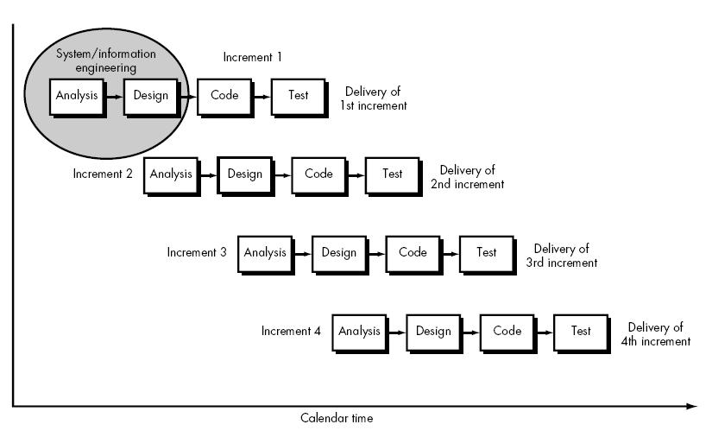

10

**3.1.1ANALYSIS PHASE**

In this phase we studied in details about the exam hall seating management system. We identified the relationship between those entities that were collected in the requirement phase. Moreover we confirmed that we can develop this system as a first project within the project schedule published by college.

**3.1.2 DESIGN PHASE**

In this phase we have performed database design for record keeping and front end design for the interaction between administration and student. Sometimes we reviewed our design if additional attributes are required or extra attributes are present in the system and also to make front end more attractive.

**3.1.3 CODING PHASE**

In this phase, we have coded the system based on the design process which we have finalized in design phase. We have used html, css, and php for coding. At first we write code for different GUI. After that we coded for details fill up form and auto seat allocation code for seat allocation for student in examination hall from the given record stored in database and finally we wrote code for database connection and for storing the entered details by admin in database. We also write code for keeping attendance of student who appeared exam.

**3.1.4 TESTING PHASE**

In this phase, the system will be tested. For this we have used details of random person data as input and verify it according to our functional requirements.

**3.2 TECHNOLOGIES TO BE USED**



CSS and HTML to develop interactive user interfaces.



PHP for retrieval and connection of database .



MYSQL for database for storing all the application data.

**3.3 TOOLS TO BE USED**

The tools used for documentation, designing and development are listed below in table:

|  |  |  |  |  |  |  |
| --- | --- | --- | --- | --- | --- | --- |
|  | **TOOLS** | |  |  | **PURPOSE** | |
|  |  |  |  |  |  |  |
|  | Microsoft Word | |  |  | Documentation | |
|  |  | |  |  |  | |
|  | PHP,MYSQL | |  |  | For web application development | |
|  |  | |  |  |  | |
|  | Xampp | |  |  | Testing suite | |
|  |  | |  |  |  | |
|  | Sublime Text/Notepad++ | |  |  | Text editor for code | |
|  |  | |  |  |  | |
|  | HTML | |  |  | To design user interfaces | |
|  |  | |  |  |  | |
|  | CSS | |  |  | To make user interface more interactive | |
|  |  |  |  |  | | |
|  |  |  | Table 1: Tools to be used | | | |

11

**4. DELIVERABLES**

By the completion of this project following things will delivered

* A software for exam hall seating management which provides the information about the students, examination details and security basis of information.
* A final report which includes all the methodologies used to prepare the project

12

**5. PROJECT TASK AND TIME SCHEDULE**

The project schedule has been designed as per requirements and constraints involved. This project is scheduled to be completed in about 2 months. Requirement analysis have been given more emphasis. Research and database management is to be done first and well documented .Debugging and Testing is to be done prior to the completion of the project.

|  |  |  |  |  |  |
| --- | --- | --- | --- | --- | --- |
|  | **TASK** |  |  | **APPROX DURATION(IN DAYS)** |  |
|  | Requirement Analysis and Specification | |  | 8 |  |
|  | Undertake Analysis of the System | |  | 8 |  |
|  | Design System | |  | 15 |  |
|  | Produce Requirement Specifications | |  | 14 |  |
|  | Testing and Debugging | |  | 8 |  |
|  | Test System Modules | |  | 7 |  |
|  | Overall System Test | |  | 6 |  |
|  | Develop Documentation | |  | 50 |  |

Table 2: Project Task and Schedule

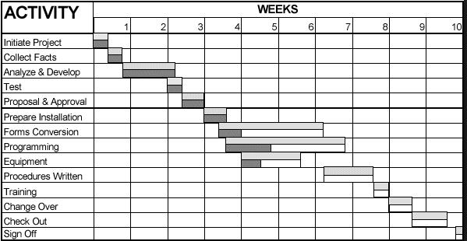

***Figure 2: Gantt Chart***

13

**6. REFERENCES**

1. "PHP and MYSQL: Working with Google Maps"*. Syntax*. [Online]. Available http://syntaxxx.com/php-and-mysql-working-with-google-maps/ [Accessed: 20- June- 2019].
2. "Programmable Web API dashboard"*.* Available http://www.programmableweb.com/apis[Accessed: 29- June- 2019].
3. " https://maxcdn.bootstrapcdn.com/bootstrap/3.3.7/js/bootstrap.min.js"[Accessed: 29- June-2019].
4. "https://ajax.googleapis.com/ajax/libs/jquery/3.3.1/jquery.min.js"[Accessed: 29-June- 2019].

14